**Marketing Plan**



**NCI LIFE**

**David Gray x13467362**

**Mubarik Nassir x14528763**

**Sean Rooney x14535717**

**David Coadey x12116793**

**Table of contents**

**Introduction** p3

*Miss*i*on statement* p3

*Layout & Visuals* p3

*Functions* p3-4

**Branding** p4

**Marketing Objectives** p5

*Schedule of Objectives* p5

**Micro-Marketing Analysis** p6

*Customer Analysis* p6

*Target Market* p6

*Market Segmentation* p6

*Target Market Approach* p7

*Customer Motivations* p7

*Competitor Analysis* p8

**Four P’s** p9

*Product* p9

*Price* p9

*Promotion* p10

*Place* p10

**SWOT Analysis** p11

**PESTLE Analysis** p12

1. **Introduction:**

This is the marketing plan for our venture NCI Life. A new application for National college of Ireland students exclusively, and available on the Google Play store. The app enables the student to manage or organise their day to day activates within the collage all on their mobile. The app has a wide variety of functions that range from signing into your lectures to topping up your library printer card.

**1.1 Our mission statement**: ‘’*NCI life is an app designed to lessen the stress and make life easier for students. This will be achieved by having an app in the palm of their hand that fills all their educational and social needs.*’’

**1.2 Layout and Visuals**

For NCI Life we used Codiqa (Mobile development tool) to create the visuals as to what the application might look like once completed.

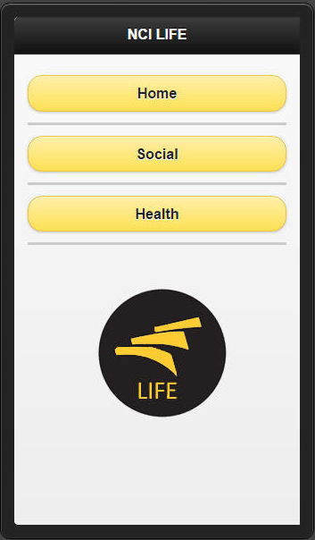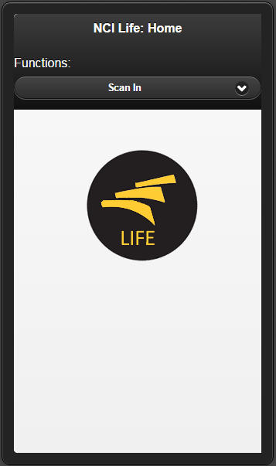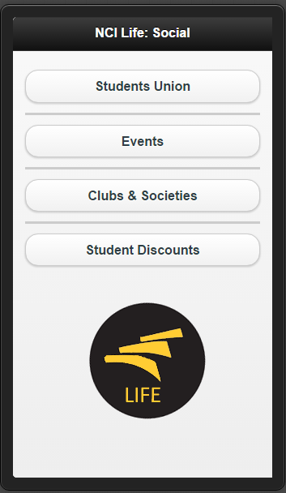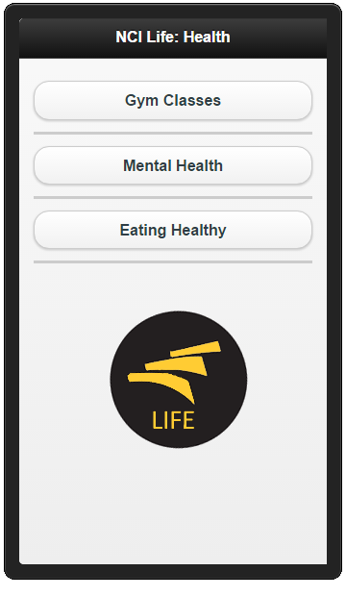

**1.4 Functions of NCI Life:**

* Access your NCI moodle page
* View course information, Exam timetables and Library Account
* Messenger function enables the user to contact their class members or lectures on their mobile. It can also contact the Student Support Services.
* Keep up to date with events in the SU, clubs and societies and student discounts
* Look up available Gym classes in SV Fitness.
* Healthy eating plans

In order to make these functions possible we will need the permission of various bodies from our NCI and the IFSC. For example, to use the NCI name and ‘Three Arch’ logo we need permission form the board of management. With the gym classes we will work with SV Fitness to get information for the classes available and the times.

1. **Branding:**

In order for our app to become successful we need to make sure our target market can recognise our brand at a glance. Visuals in marketing are vital for attracting interest in our brand. We want to create and educational but also stress free identity with the app. If the students of NCI download the app they will have stress free days in college and who doesn’t want that? Our logo is based on the NCI logo, therefore NCI students who see our advertising around the college will recognise our brand straight away. This is the main reason why we chose our logo. It’s simple and at the same time catches the consumer’s eye.



**‘’*You’re Life in Your Hands* ‘’**

Our slogan is based on our mission statement but obviously simplified:

If we are successful with the launch of a service like NCI life provides we can easily adapt our slogans, logos and visuals to other colleges around the country if they wish to have an ‘NCI Life’ like application for their students. This method of market segmentation is called distribution segmentation. We will still brand our app as ‘Life’ but instead of ‘NCI Life’ we could make a ‘DIT Life’ or ‘TCD Life’ for example.

We hope that if we are successful with branching out to other colleges that our brand will be recognised in the majority of major colleges in Dublin and the rest of Ireland.

1. **Marketing Objectives**

Our objective we aim to achieve through our marketing of the NCI life application is to gain the majority market share of NCI students within our first year of operations. This is crucial to the applications survival because if there is no interest in the app, the college will remove the system completely as it would be a waste of their financial resources.

* 1. **SMART Objectives:**

As a group we feel our objectives are attainable with the help of our current marketing plan. We used the SMART (specific, measureable, attainable, realistic, time) system to help plan our future goals.

**S -** We planned exactly what needs to be done with the application. From creating brand awareness to attaining NCI users every aspect of this applications marketing plan is specific and important.

**M –** Refers to how the apps progress can be measured. We aim to gain up to 1,000 students in every quarter. NCI Life has the potential attract even more so this objective is attainable.

**A –** As an application, NCI Life will inevitably be known throughout the college. With our marketing and promoting techniques our objectives will be attainable.

**R –** Having realistic goals in not only good planning but also good for moral. Our set objectives are realistic and achievable.

**T -** We believe that having our objectives set out through quarters gives us enough time to achieve them.

* 1. **Schedule of dates for objectives:**
* **1st Quarter:** Successfully deploy the app and fix all bugs as they are discovered and have at least 1,000 students actively using NCI Life.
* **2nd Quarter:** Have a fully updateable SU page that SU Executive can update as they wish, moving our workload to the people who work with the SU on a day to day basis which will free up our time to contact other colleges about our application.
* **3rd Quarter:** If they app is running smoothly and gained interest from NCI students, we will contact other colleges in the Dublin area to put forward an app for their customers. Their students.
* **4th Quarter:** By this stage of operations we plan on having fully functional ‘Life’ applications in NCI and at least one other college. In this month we will also seek to re-new any student deals we have with business around the city centre and IFSC for new incoming students and current ones

1. **Micro-marketing analysis:**

**Customer Analysis:**

***Target market***

The target market we will be aiming for is that of the college student, this demographic consists of a large market of primarily young people, often with low income, who have hectic and busy lifestyles and are often in busy town or city environments. Students typically have a large workload of assignments, projects and exams, as well as trying to balance a social life and very often holding down a part time job on top of it all. Our product, the NCI Life app, will help to relieve some pressure and make easier the day to day life of the college students.

The main four criteria that help a customer to distinguish and choose a product are: Price, Quality, Convenience and Prestige. As our app has no price and is free to download this will appeal to our target market, as students often do not have a lot of money and try to limit their spending on goods and services, this will eliminate a barrier into the market.

As our product is aiming to lessen the stress and make life easier for students it will definitely check the box for convenience. As it is an app that is downloaded onto your phone, and students always have their phones with them, it will be simpler than ever to check matters related to college life, which is extremely convenient for the students of today who are busier than ever and always on the go.

As for prestige, we all know a presentation is everything, if it doesn’t look good, then it will give the impression that it’s not good. We will be using a layout and visuals that are bright and fun and that will appeal to our target market which is a mostly young generation. We will top it off with attractive graphics and sounds without creating unnecessary distractions, we will also be promoting student deals for various shops and bars around Dublin, which of course will also help to attract students, who love a good deal.

***Market segmentation***

As well as psychographic, demographic and geographic segmentation which I have touched off above, we will also be availing of distribution segmentation. By this I am referring to brand name. Our app is being called NCI Life, but that will solely be for the students of NCI. If and when we branch out to other colleges we obviously cannot sell our product under the same name, therefore when we are distributing our product to other colleges we will of course need to change the brand name, for example DIT Life. It will still hold some similarities but will be branded differently and sold to a different segment of our target market, ie DIT students, as opposed to the students of NCI.

***Target Marketing approach:***

The target market approach we will be using is focused/concentrated marketing.

Our company, for the start anyway, will solely be focusing on one segment of the market. As our product is unique, and tailored for a specific target market it will make it extremely difficult to sell to other segments of the market. The Life App can only really be targeted to college students, other market segments will not be interested in this product.

One advantage of this approach, is that since we are only targeting a specific segment of as market, as opposed to several, it allows us to put all our energy and pour all our resources into developing this product, and understanding and meeting the needs of our target market. Being able to focus solely on a narrowly defined segment give us the advantage of being able to capitalise on the target market and to provide an exceptional product to meet all the needs of that market.

If our research pays off and our product is a success, we will then be able to evolve and grow and produce other products to meet the needs off this target market. Having previously tailored to this market it will be easier to develop products to meet their needs as we will already have an understanding of the market segment, how they think, and what they need. Also there will be brand recognition, and a sense of trust for our company, as the market segment will already be familiar with, and trust one of our products which will give us an added advantage in the future.

However there are some disadvantages to this marketing approach, one being that if our app is to be a big success, it may attract unwanted attention from other and larger organisations who could then try to enter the market and leech off our success by stealing our customer base. Another issue is that if the market does not respond positively and there is not a huge demand for our product then we will be dead in the water as we cannot target another segment, unless we attempt to tailor or product or develop a new one.

Also there is there possibility that, having tailored to the needs of a particular segment for so long, it will be extremely difficult for us to target other markets should we wish to branch out and develop products for other market segments. If we become too affiliated with and identified as providing to a particular target market, other market segments may see us as not being able to adjust to and tailor to their needs and produce quality products for that market.

***Customer Motivations*:**

We believe that customers will be motivated to download our app for a number of reasons, mainly because it is an advanced and unique product created specifically to their needs and will help easy their workload and provide easy access to essential materials. It is also free to download and will provide good student discounts that the customer can avail of. It will also provide better means of socialising in and out of college which is always an appealing factor to the younger generation, you can see from the success of Facebook and other social media apps that have been a huge success in recent years.

***Competitor Analysis*:**

Our app doesn’t necessarily have any main competitors, none that would be a threat to our success. As we currently will be producing the only mobile app for colleges, the market is ours to capitalise on, there are no other alternatives for our app. The only thing that could be considered a competitor at the moment would be the student portal which we do not see as being a major threat to our operation. The only strengths that the student portal would have over NCI Life at present would be that it is a recognised brand that has a large customer following, and that since it is launched by the college itself it may be privy to more information. However there are many weaknesses to the student portal, mainly that it is only accessible via desktop or laptop, a lot of the content doesn’t work as it should, and also a lot of the information and services are redundant or unnecessary.

**Product**

The product we are launching is a free app that is going to be exclusive to NCI students and will be available on the Google play store. This app will allow student to manage their day to day activates needed for college life all on their mobile phones. The app will have wide selection of function that range from access your Moodle page, singing into class , view course Information , keep update with students events,  messenger function which will allow the user to communicate with their class mate or lectures can contact their student if running late or class is cancelled. The unique selling point of our app is the easy access where by students can find any required information within a tab, with our app you will be constantly logged on unless you decide to log out yourself .i.e. messenger and snapchat app .

”NCI life is an app designed to lessen the stress and make life easier for students. This will be achieved by having an app in the palm of their hand that fills all their educational and social needs.’’

We predict that our target market will download our app due to our service filling the gap in the market and most of all the necessity it has for college life. Studies show the average person spends eight hours and twenty-one minutes on their phone and with majority of student owning their own smartphone you can see why we are so optimistic about our business venture.

**Price**

The app is going to be free as discussed above; for comparison reason we couldn’t find any other app companies to compare it to that offered similar service as ours. The reason being is that are app is going to be exclusive to NCI College. The means of how we generate revenue form the app was established by in-app advertisement and in-app purchases, for the in-app advertisement we used a mobile ad network “ADMOB”. This network offer easy integration which means that we start earning revenue almost immediately and also “ADMOB” brings together best-in-class technology in a single platform, which also help us get an insight about our user. There are two tactics in which made revenue by for in-app advertisement which are cost per impression (CPM) and cost per click (CPC). We charge at rate of **€1** “CPM” which means the businesses that advertise on our app pay us **€1** for every 1,000 clicks of its ad. The ratio in which we get our “CPC” is per click we generate **€2.50** which is where a big chunk of the revenue will be coming form for this venture. The in-app purchases was difficult as we had to create a payment system which required a payment-holding, this meant that we had to do business with PayPal which involved us giving some of the money we make. The ration in which made returns on this was for every euro they top up on their student library account we made **5c** on it.

**Promotion**

There were many different methods we could have used to notify our customer or stakeholders about the service we provide. We had to conduct intense research on how to carry out suitable advertising and effective promotion to influence the customer rational about our service. We put in place several promotion method that met the needs of our target market, which includes advertisement, lucky draw and usable benefits. Advertising was carry out in many way where we make Facebook and twitter page to get the word out and also posted on the NCI Facebook page. Our promotion launch was set for the start of college year were we had I stand to communicate to our target market which includes first year, current student and lectures. We also put posters all around the college campus and advertised on the NCI home page to emphasis the technology benefits of our app to target market. To ensure we maximise our customer base we used lucky draw method were by we gave away free pizza slices to anyone who downloaded our app and were also entered into raffle draw were they would win an xbox1 and also PlayStation4.

**Place**

Student will able to download our app form the google play store which will free for them. The first stage of our business venture we will solely be operating in the NCI market providing solely to NCI students and lectures. The app is going relevant to NCI student as they access on to student port without the need to NCI web page.

**SWOT & PESTLE Analysis:**

   
**Strengths**    
   
Our main strength, and objective, is how we can make college life easier on students. First we assessed how barely anyone checks their student emails and thought that by adding a way in the app that students could talk to their lectures in an easier and quicker way could be beneficial, thus we added an instant messaging system. Students can not only use it for lectures but can also use it for talking to classmates. We also wanted an easier way for students to be able to find out with what's going on in the college and what events are coming up. Students can also check and top up library card balance. This app will make it easier for students, by having college information on their phone, rather than having to log into the student portal on a PC.  
   
    
 **Weaknesses**   
   
With this being a new app it may take some time for people to identify with it and come around to the idea of using it. There may be some students who might not like the idea of using the app and would want to stick to what they know. Debugging code could potentially be a problem in the start-up phase.

**Opportunities.**   
   
There is a gap in the market for our product. We noticed that NCI, and no other college has an app that meets the requirements of its students. We plan to test it out in NCI first and if we have a good enough response we will bring the idea of our app to other colleges around the country. With no competition we have a chance to branch in the market out and get other colleges interested in using the app. 

**Threats**   
   
One of the threats might be the college not allowing us to use the college name and information in the app. This would be a big factor in proceeding with the app.  Also, if our app is a recognised success at NCI, it is possible other colleges could develop their own apps before we get the chance to approach them.   
    
 

**PESTLE Analysis:**

**Political**    
   
For the NCI life app we will need permission from NCI to obtain the information we need and the use of their logo. The college will be asking themselves will NCI Life’s features be beneficial to our students. Increasing college fees by successive governments has put a greater financial burden on students and this means they would be looking to save money and use the discount features on our app.  
   
    
**Economical**   
   
To generate revenue our plan is to work with businesses around the IFSC and create promotions and discounts for NCI students. We will be advertising these businesses in the app which will hopefully increase awareness about the businesses around the area.

**Social**  
   
We feel that the app will do well as most people have smartphones and use apps on a day to day basis, we feel that students will want to use the app that since it is going to make their experience in college a lot easier. People are using the internet and socialising on apps more and more, hence we provide an instant messenger service.  
 

**Technological**    
   
In this day and age the majority of people have smartphones and apps make our life easier. The app is also easily available on the Google Play store which is a popular medium for downloading applications.  
 

**Legal**   
We would also need to get permission from the college to use the ‘Three Arch’ logo. We will have a secure login so that student’s information is safe and protected.

**Environmental**    
   
With majority of students having mobile phones and tablets with them in college the app will allow students to get the information they need there and then. This app reduces the need for students to have to log onto a computer to view the information they require.